## Identifying Stale EBS Snapshots

I have created a Lambda function that identifies EBS snapshots that are no longer associated with any active EC2 instance and deletes them to save on storage costs.

Steps done:

Created a Ec2 instance with the default volume

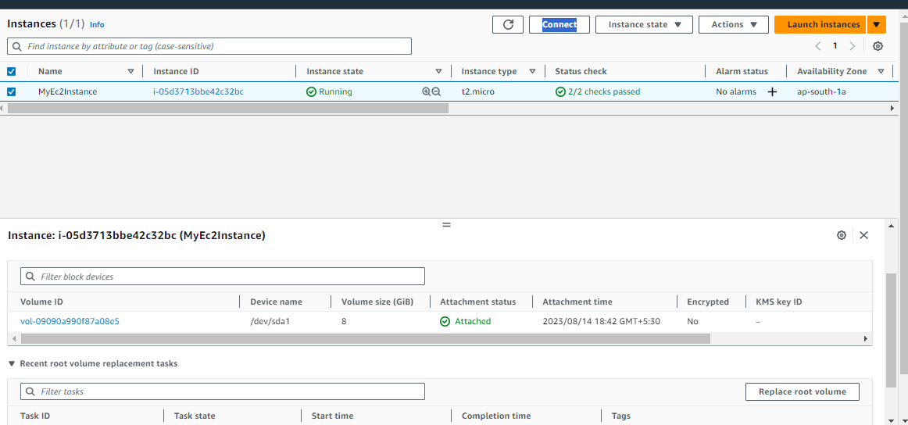

Created one more volume and it is not attached to any EC2 instance

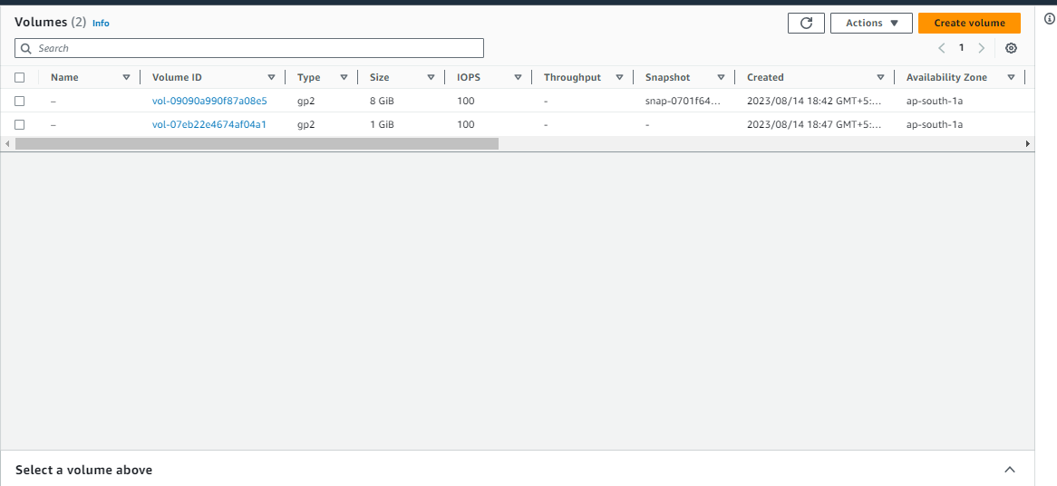

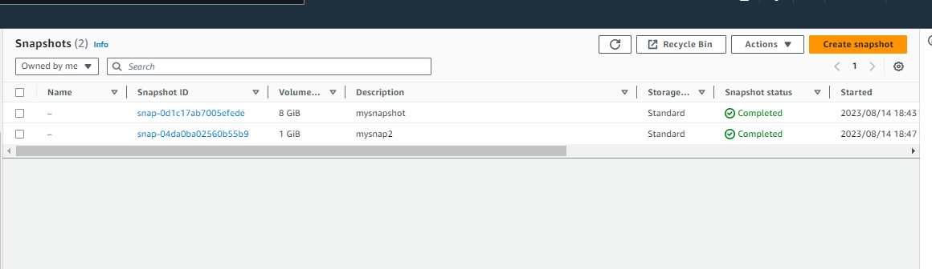  
  
I have taken snapshots from each volumes as below

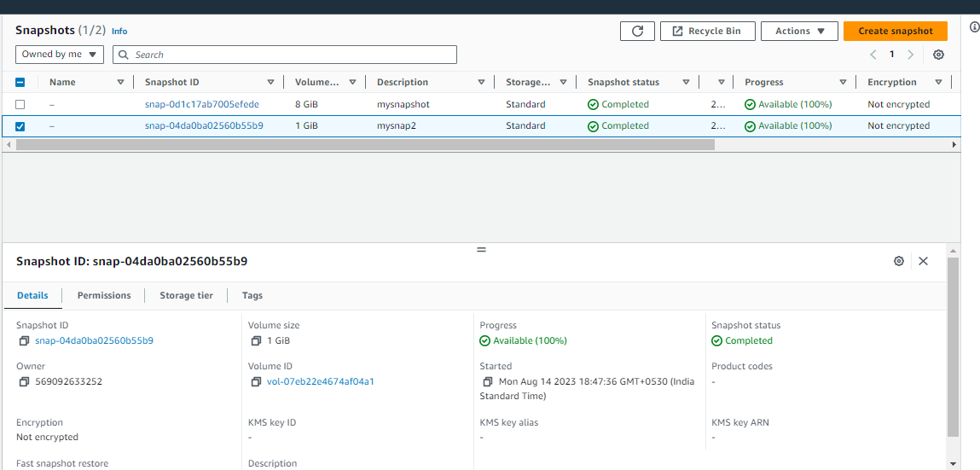

Created a Lambda function which fetches all EBS snapshots owned by the same account ('self') and also retrieves a list of active EC2 instances .

For each snapshot, it checks if the associated volume is not associated with any active instance.

If it finds a unused snapshot snapshot, it deletes 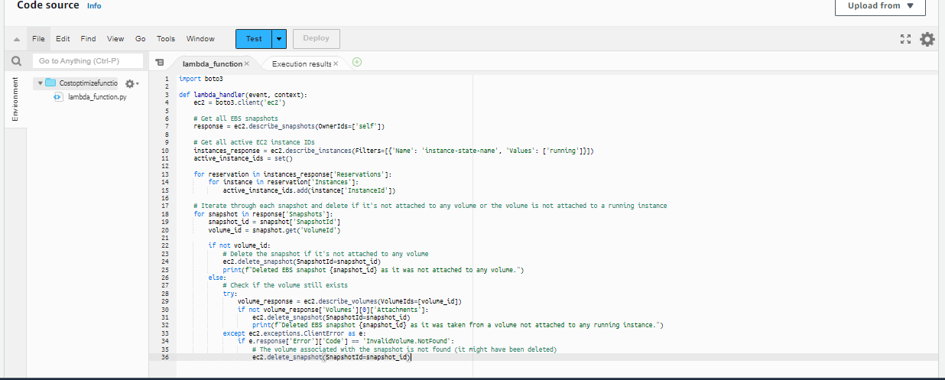

If I test the code in lambda function , one of the snapshot got deleted .

The snaphot volume is not attached to any Ec2 instance . So it got deleted

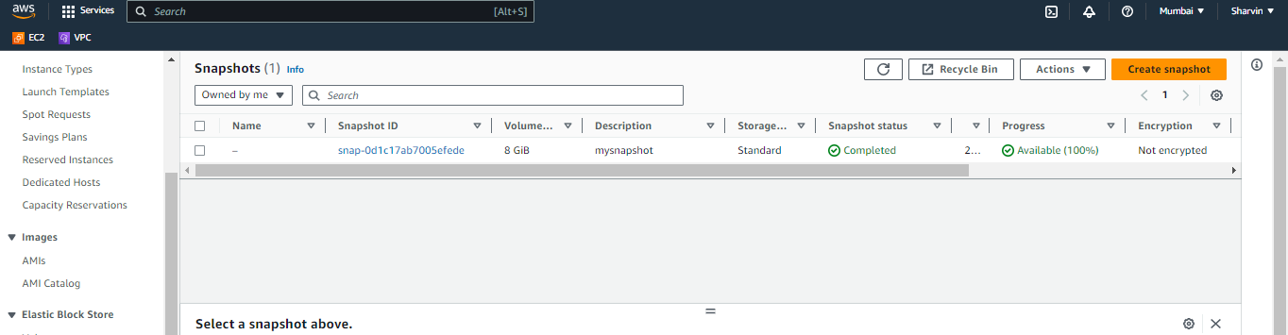

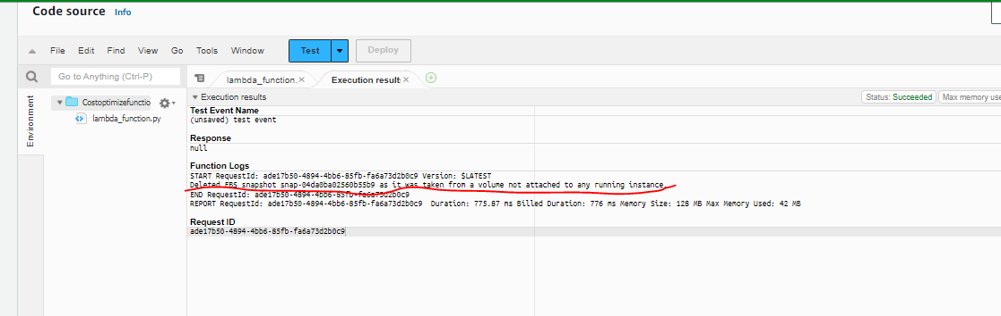  
  
Later , I have terminated the Ec2 instance for checking. If I run the test case , the snaphot for this ec2 instance volumes needs to be deleted as per code.

Because while deleting the instance, the default volume will get deleted. So the volume of the snapshot is not attached to any running Ec2 instance. So it got deleted.

